**SEARCH AN INCIDENT WITH A GIVEN INCIDENT ID AND CHECK THE STATUS . IF IT IS IN “RESOLVED ” STATUS AND RESOLVED DATE IS OVER 3 DAYS MAKE IT CLOSED ELSE DISPLAY THE STATUS OF THE INCIDENT.**

**function** test(id )

{

**var** i = **new** SCFile("probsummary"); // used for choosing new object of table (file)

**var** query="number= \""+id+"\"";

**var** rc=i.doSelect(query); // used in query execution

**if**(rc==RC_SUCCESS)

{

pr="tod()";

d=**new** XMLDate(system.functions.parse_evaluate(pr,6));

d1=d.getSCDateTimeString();

**if** (i.problem_status=="Resolved")

{

yday=system.functions.dayofyear(i.resolved_time);

yday1=system.functions.dayofyear(system.functions.tod());

**if** (yday1-yday>=3)

{

i.problem_status="Closed";

i.flag=**false**;

i.status="closed";

i.doUpdate();

print("Status has been changed from Resolved to Closed");

}

}

**else**

{

print("Current Status :"+i.problem_status);

}

}

}

test("IM000000023");

LEARNING :

* Return codes

1. RC_ERROR //to check if any error has occured
2. RC_SUCCESS
3. RC_CANT_HAVE //to check if resources are available or not
4. RC_NO_MORE //to check if any record is available in record set
5. RC_DUPLICATE_KEY
6. RC_MODIFIED
7. RC_DELETED

* For calling RAD functions and RAD variables in a java script.

1. For functions ,use – system.function.function_name_used_in_RAD().
2. For variables ,use – system.variable.variable_name_used_in_RAD().

* Usage of field name in RAD and JS is different.

1. In RAD- resolved.time
2. In js - resolved_time

* Things involved in this question

1. While changing the status of the ticket SLA is involved i.e Due to SLA applied we are checking whether the ticket will be closed or open . So go to

AlertDef –check for conditions applied over there on SLA.

1. Found that flag and status are used in condition . Now check the values and change the values accordingly . Here the value of flag is set to “false ” and status to “close ” for closing the ticket.

**FUNCTIONS USED**

* SCFile()- An object of this has to be created to access any file in SM.

SYNTAX:

Var a = SCFile(“filename”);

* SCDatum()-An alias of SCFile().

SYNTAX:

Var a = SCDatum();

* Array. getSize()- This function is used to get size of an array.
* Tod()- To get current date and time .
* operator()-To get the name of the operator.
* XMLDate()- converts js date object to the XMLDate object.

SYNTAX:

d=**new** XMLDate(system.functions.parse_evaluate(pr,6));

d1=d.getSCDateTimeString(); // gives formatted date

* Dayofyear()- To find the day of that particular year.

**ADD THE ACTIVITY UPDATE ON THE CLOSED INCIDENT**

**function** test(id )

{

**var** i = **new** SCFile("probsummary"); // used for choosing new object of table (file)

**var** query="number= \""+id+"\"";

**var** rc=i.doSelect(query); // used in query execution

**if**(rc==RC_SUCCESS)

{

**if** (i.problem_status=="Resolved")

{

yday=system.functions.dayofyear(i.resolved_time);

yday1=system.functions.dayofyear(system.functions.tod());

**if** (yday1-yday>=0)

{

i.problem_status="Closed";

i.flag=**false**;

i.status="closed";

i.doUpdate();

**var** j = **new** SCFile("activity");

j.number =id;

print(id);

j.type="Update"

j.datestamp=system.functions.tod();

j.operator=system.functions.operator();

j.cust_visible=**false**;

**var** arr= **new** Array();

j.description[0]="Status changed from Resolved to Closed"; r=j.doInsert();

**if**(r==RC_SUCCESS)

print("activity");

print("Status has been changed from Resolved to Closed");

}

}

**else**

{

print("Current Status :"+i.problem_status);

}

}

}

test("IM000000023");

**ADD THE JOURNAL UPDATE ON THE CLOSED INCIDENT**

**function** test(id )

{

**var** i = **new** SCFile("probsummary"); // used for choosing new object of table (file)

**var** query="number= \""+id+"\"";

**var** rc=i.doSelect(query); // used in query execution

**if**(rc==RC_SUCCESS)

{

print(i.update_action.getSize()); //to get the size of the array

print((system.functions.tod()));

pr="tod()";

d=**new** XMLDate(system.functions.parse_evaluate(pr,6));

d1=d.getSCDateTimeString();

**if** (i.problem_status=="Resolved")

{

yday=system.functions.dayofyear(i.resolved_time);

yday1=system.functions.dayofyear(system.functions.tod());

**if** (yday1-yday>=0)

{

i.problem_status="Closed";

i.flag=**false**;

i.status="closed";

**for**(k=i.update_action.getSize()+3;k>2;k--)

{

i.update_action[k]=i.update_action[k-3];

}

i.update_action[0] = d1+" ("+system.functions.operator()+"):";

i.update_action[1] ="Auto Closed Incident as the Resolve time is greater than 3 days. ";

i.update_action[2] = " ";

i.doUpdate();

**var** j = **new** SCFile("activity");

j.number =id;

print(id);

j.type="Update"

j.datestamp=system.functions.tod();

j.operator=system.functions.operator();

j.cust_visible=**false**;

**var** arr= **new** Array();

j.description[0]="Status changed from Resolved to Closed"; r=j.doInsert();

**if**(r==RC_SUCCESS)

print("activity");

print("Status has been changed from Resolved to Closed");

{

}

**else**

{

print("Current Status :"+i.problem_status);

}

}

}

test("IM000000023");

CREATE A JS , FIND INCIDENT ID WHICH WERE CLOSED IN LAST 7 DAYS

**function** test()

{

**var** count=0;

**var** x= **new** SCRecordList("probsummary",**new** QueryCond("problem.status",'=','Closed'));

print("Total record in the list: " + x.getCount());

**for** (j **in** x )

{

yday1=system.functions.dayofyear(system.functions.tod());

yday=system.functions.dayofyear(x[j].close_time);

**if** ((yday1-yday<8)&&(yday1-yday>=0))

{

print(x[j].number +"closed on "+x[j].close_time );

count++;

}

}

print(count);

}

test();

RESULTS:

2

IM000000073closed on Wed Feb 24 2016 07:46:52 GMT+0100 (CET)

IM000000023closed on Fri Feb 19 2016 05:29:44 GMT+0100 (CET)

Total record in the list: 44

FUNCTIONS USED:

SCRecordList(<table name >, <QueryCond>)-it will fetch multiple records in a go from the database.

< QueryCond >= new QueryCond(<condition>)

<SCRecordList Object>.getCount()-It will get the count of the records fetched with in the SCRecordList.

**CREATE A BUTTON THAT IS VISIBLE WHEN AN INCIDENT IS IN “WORK IN PROGRESS” .IT SHOULD BE ONLY VISIBLE TO THE SYSTEM ADMINSTRATOR. THE BUTTON SHOULD TRIGGER A NOTIFICATION TO THE CONTACT OF THE IM , NOTIFYINGT TICKET HAS BEEN UPDATED AND ALSO DISPLAY A MSG FOR THE SAME .**

**function** test(record )

{

**var** i = **new** SCFile("probsummary");

id=record[ 'number' ];

print(id);

**var** query="number= \""+id+"\"";

**var** rc=i.doSelect(query);

**if**(rc==RC_SUCCESS)

{

rteNames = **new** SCDatum ();

rteValues=**new** SCDatum();

rteValues.setType(8);

rteNames.push("name");

rteNames.push("record");

rteNames.push("second.file");

rteValues=system.functions.insert(rteValues, 0, 1, "testgarima");

rteValues=system.functions.insert(rteValues, 0, 1, i);

rteValues=system.functions.insert(rteValues, 0, 1, i.save);

system.functions.rtecall("callrad",**new** SCDatum(),"us.notify",rteNames,rteValues,**false**);

}

**return** 1;

}

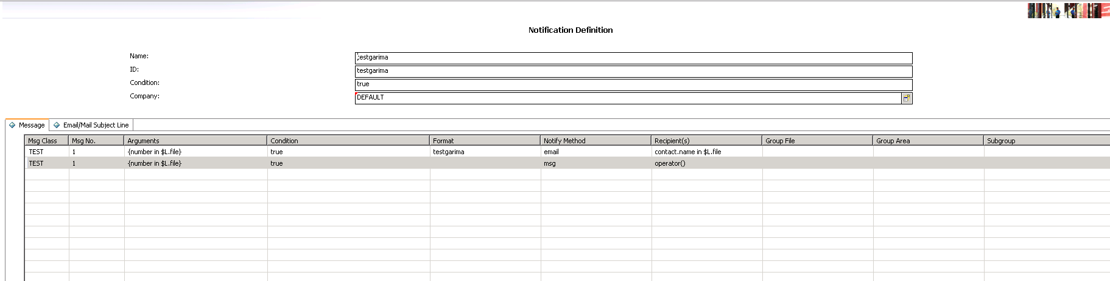

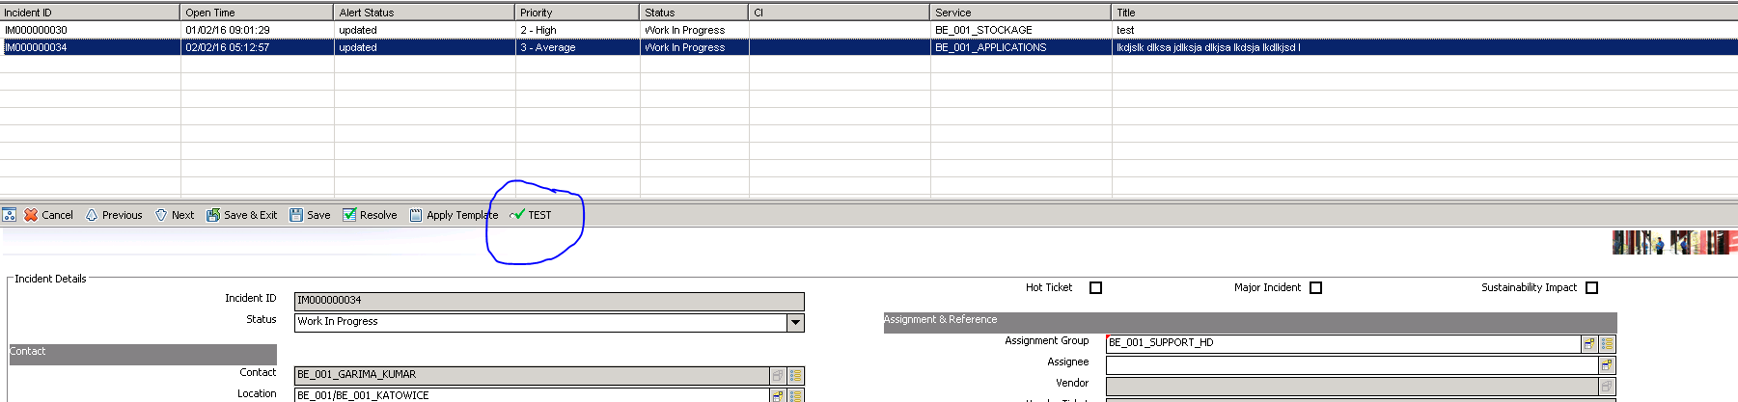

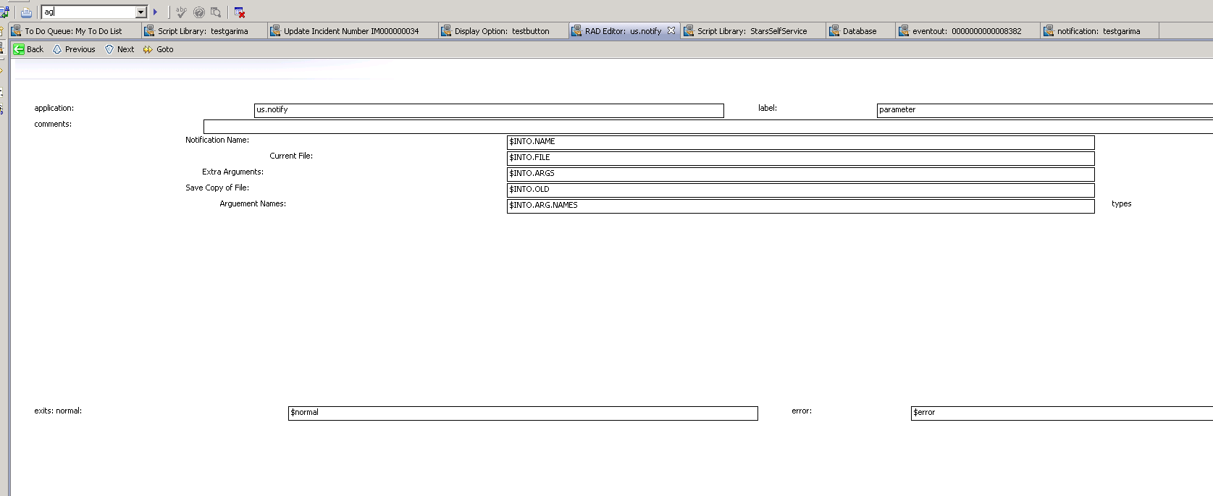

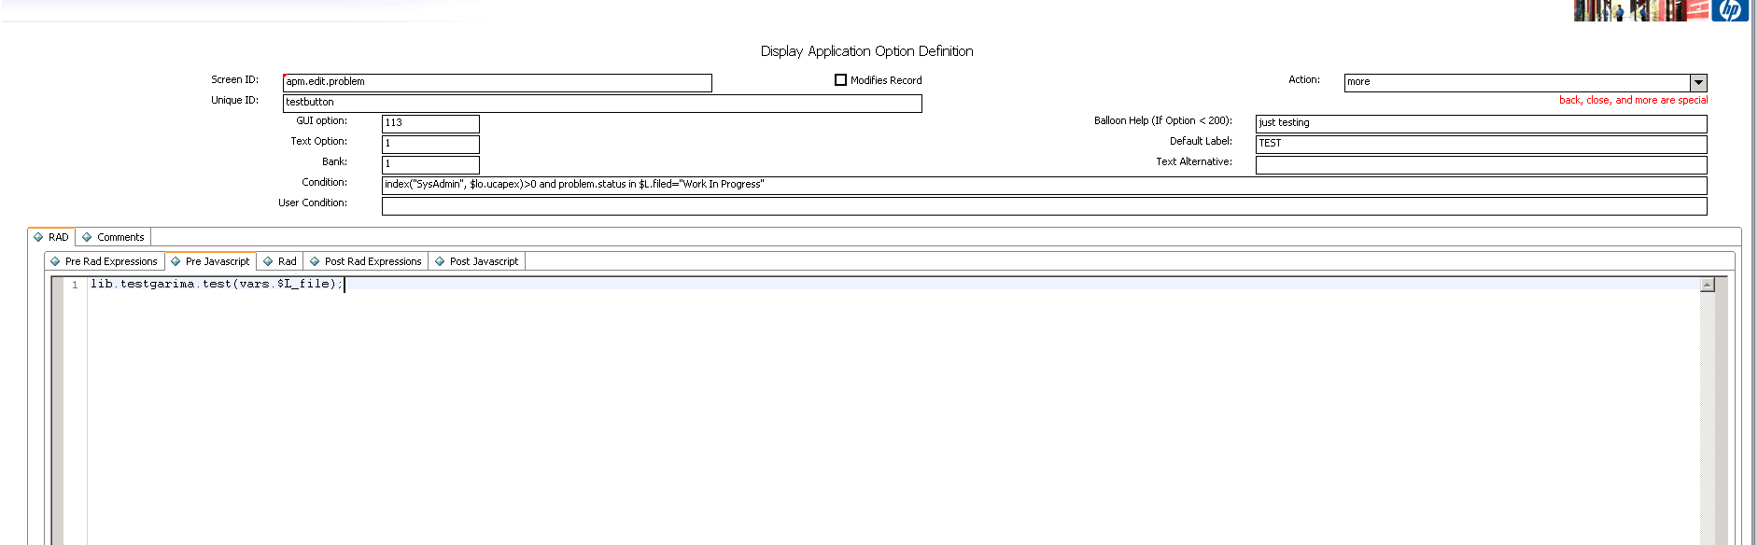

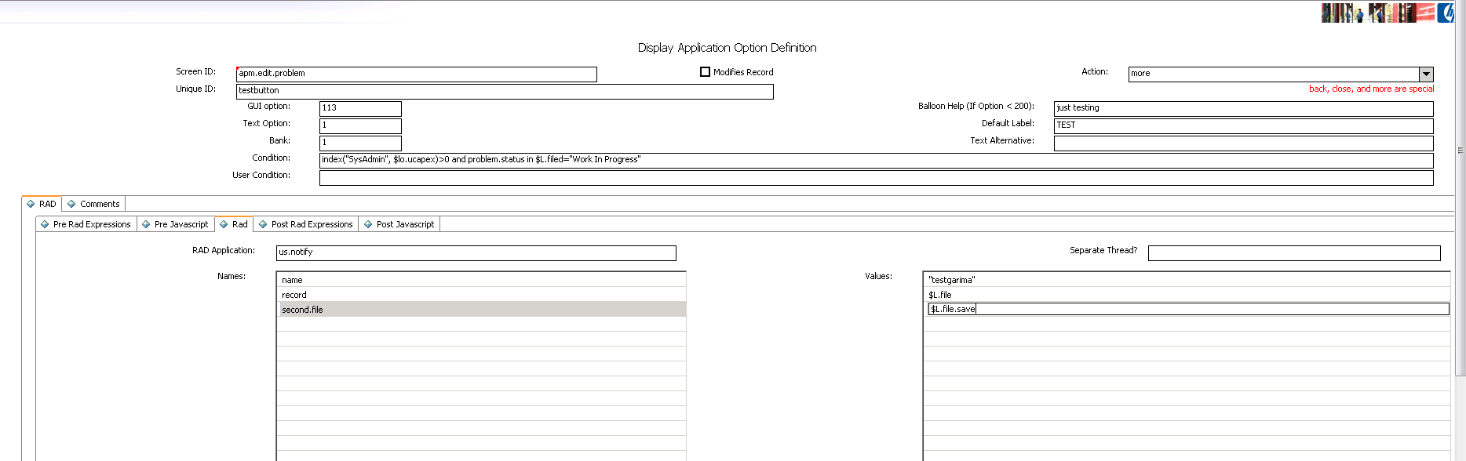

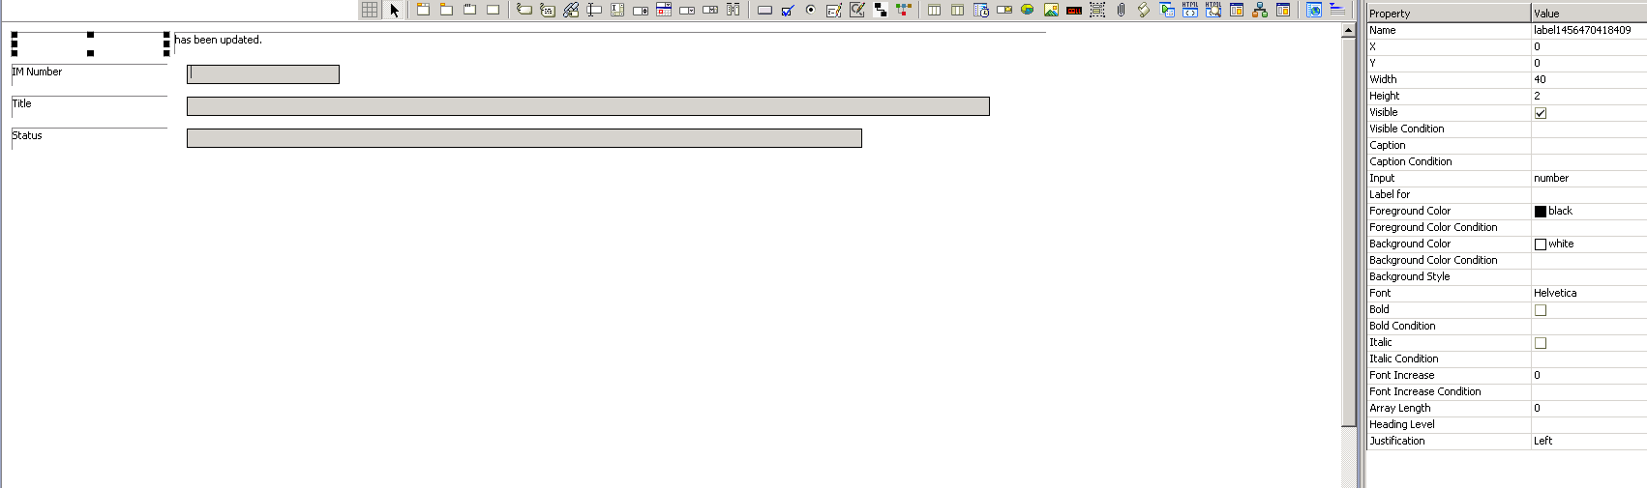

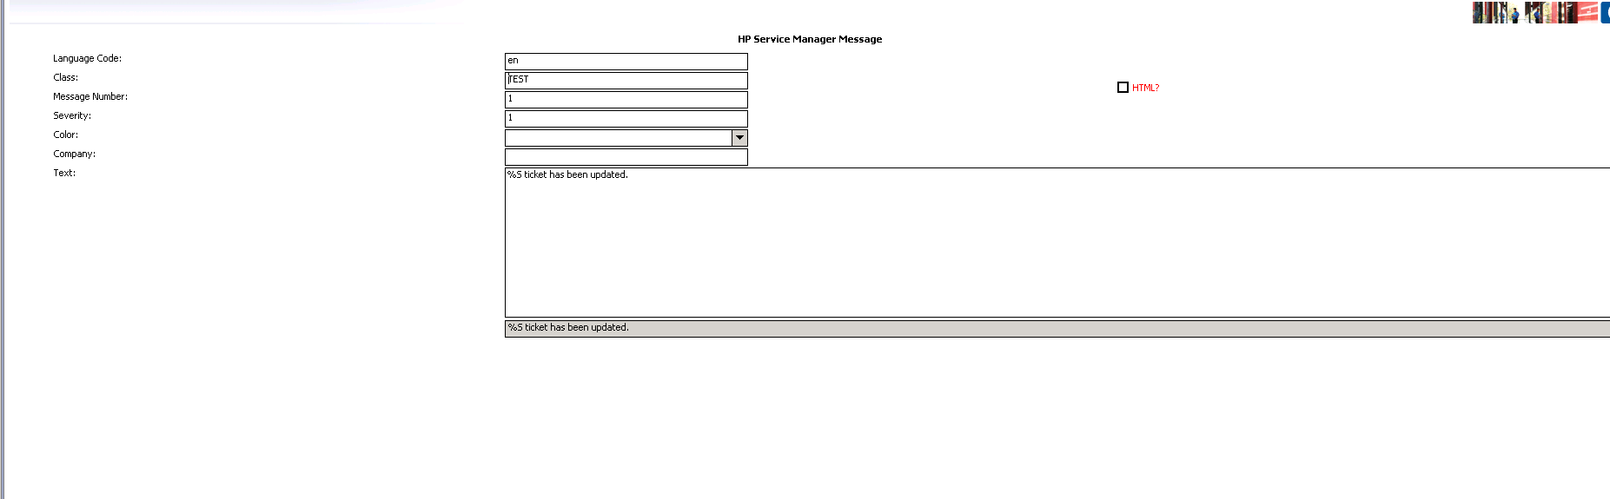

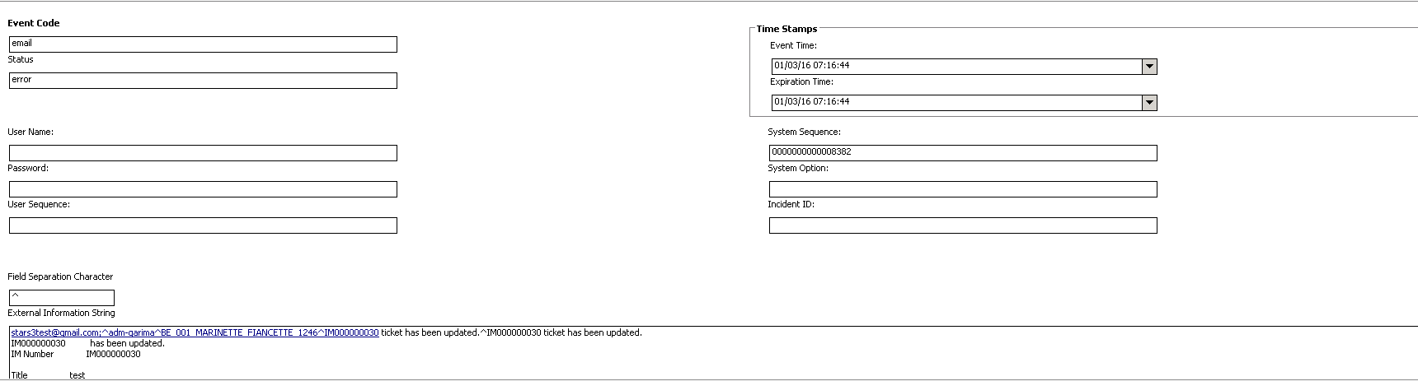

FUNCTIONS USED:

Var.setType(num)🡪 Sets the datatype of the variable

**function** test(id)

{

i= **new** SCFile("probsummary");

j=**new** SCFile("incidents");

**var** query="number=\""+id+"\"";

rc=i.doSelect(query);

**if**(rc==RC_SUCCESS)

{

yday=system.functions.dayofyear(system.functions.tod());

yday1=system.functions.dayofyear(i.resolved_time)

print(yday1);

**if**(yday-yday1>=0)

{

i.problem_status="Closed";

i.flag=**false**;

i.status="closed";

i.doUpdate();

print("relqted one--");

str= **new** String();

str="SD";

**if**(system.functions.substrb(i.incident_id, 1, 2)==str)

{

print(i.incident_id);

query="incident.id=\""+i.incident_id+"\"";

r=j.doSelect(query);

**if**(r==RC_SUCCESS)

{

print(j.open);

j.open="Closed";

j.doUpdate();

}

}

}

}

test("IM000000038");

**function** **test**(id )

{

**var** i = **new** **SCFile**("rootcause"); // used for choosing new object of table (file)

**var** query="id= \""+id+"\"";

**var** rc=**i.doSelect**(query); // used in query execution

**if**(rc==RC_SUCCESS)

{

**var** nwd=((i.stars_due_date - **system.functions.tod**()));

**print**(nwd);

**var** day = **Math.floor**(nwd/1000/60/60/24);

nwd -= day*1000*60*60*24;

**var** hr = **Math.floor**(nwd/1000/60/60);

nwd -= hr*1000*60*60;

**var** m = **Math.floor**(nwd/1000/60);

nwd -= m*1000*60;

**var** s = **Math.floor**(nwd/1000);

**print**("day"+day);**print**("hr"+hr);**print**("m"+m);**print**("s"+s);

diff=**system.functions.dayofyear**(i.stars_due_date)-**system.functions.dayofyear**(**system.functions.tod**());

**print**(diff-1);

**print**(**system.functions.dayofyear**(**system.functions.tod**()));

**print**(**system.functions.dayofyear**(i.stars_due_date));

val=(diff-1)+" "+hr+":"+m+":"+s;

**print**(val);

**var** dat= **new** **Date**();

dat=val;

**print**(dat);

/*Date.daysBetween = function(date1,date2 ) {

//Get 1 day in milliseconds

var one_day=1000*60*60*24;

// Convert both dates to milliseconds

var date1_ms = date1.getTime();

var date2_ms = date2.getTime();

// Calculate the difference in milliseconds

var difference_ms = date2_ms - date1_ms;

print(difference_ms);

print(date1);

print(date2);

print(date1-date2);

//take out milliseconds

difference_ms = difference_ms/1000;

var seconds = Math.floor(difference_ms % 60);

difference_ms = difference_ms/60;

var minutes = Math.floor(difference_ms % 60);

difference_ms = difference_ms/60;

var hours = Math.floor(difference_ms % 24);

var days = Math.floor(difference_ms/24);

return days + ' days, ' + hours + ' hours, ' + minutes + ' minutes, and ' + seconds + ' seconds';

}

//Set the two dates

var y2k = new Date(i.stars_due_date);

var Jan1st2010 = new Date(y2k.getYear() + 10, y2k.getMonth(), y2k.getDate());

var today= new Date();

//displays "Days from Wed Jan 01 0110 00:00:00 GMT-0500 (Eastern Standard Time) to Tue Dec 27 2011 12:14:02 GMT-0500 (Eastern Standard Time): 694686 days, 12 hours, 14 minutes, and 2 seconds"

print('Days from ' + Jan1st2010 + ' to ' + today + ': ' + Date.daysBetween(Jan1st2010, today));

finaly=function(duration) {

var seconds = parseInt((duration/1000)%60)

, minutes = parseInt((duration/(1000*60))%60)

, hours = parseInt((duration/(1000*60*60))%24)

, days = parseInt(duration/(1000*60*60*24));

var hoursDays = parseInt(days*24);

hours += hoursDays;

hours = (hours < 10) ? "0" + hours : hours;

minutes = (minutes < 10) ? "0" + minutes : minutes;

seconds = (seconds < 10) ? "0" + seconds : seconds;

return hours + ":" + minutes + ":" + seconds;

}

print(finaly(nwd));

*/

}

}

**test**("PM000000013");

/*var count=0;

function test()

{

var x= new SCRecordList("slo",new QueryCond("service.area",'=',"rootcausetask"));

print("Total record in the list: " + x.getCount());

for (j in x )

{

print(parseInt(x[j].slo_id));

test1(parseInt(x[j].slo_id));

}

}

function test1(id)

{

var i= new SCFile("slo");

var query="slo.id =\""+id+"\"";

rc=i.doSelect(query);

{

if(i.service_area=="rootcausetask")

{

if(i.initial_state=="Open")

count++;

print("yes"+i.name);

}

else

print("no");

}

print(count);

}

function test()

{

var x= new SCRecordList("slo",new QueryCond("service.area",'==',"rootcausetask"));

print("Total record in the list: " + x.getCount());

for (j in x )

{

if(x[j].initial_state=="Open")

{

x[j].initial_state="Ready";

// rt=x[j].doUpdate();

// if(rt==RC_SUCCESS)

// print(x[j].slo_id+"-->"+x[j].initial_state);

}

}

print("Total record in the list: " + x.getCount());

}

test();

*/

**function** **test2**()

{

**var** count=0;

**var** i= **new** **SCFile**("slo");

query="service.area = \"rootcausetask\" and initial.state = \"Open\" ";

rc=**i.doSelect**(query);

**while**(rc==RC_SUCCESS)

{

**if**(rc==RC_SUCCESS)

{

**print**(i.name+"-"+i.initial_state);

count++;

**print**("yes");

}

**i.getNext**();

}

**print**(count);

}

**test2**();

View Default is used for containing records for the inbox’s default view .

**function** test()

{

**var** count=0;

**var** x= **new** SCRecordList("ViewDefault",**new** QueryCond("name",'!=',''));

print("Total record in the list: " + x.getCount());

**for** (j **in** x )

{

r=x[j].doDelete();

**if**(r==RC_SUCCESS)

print("deleted");

}

print(count);

}

test();

///////////////////////////////////////////// to create genric functions

Syntax

Var req = new (‘request’);

req[field]= ….

Where field is the field you wanna assign

Like

req[‘number’]=”RF1”;

///////////////////////////////////////////// functions to be used when n where

System.functions.same – to compare date / time coz in js it does not compare date directly if u do date1~= date2